# Bidirectional causal between AN and MDD: a bidirectional two-sample Mendelian random analysis

**Abstract**:

**Background:**

The frequent co-occurrence of anorexia nervosa (AN) and major depressive disorder (MDD) poses challenges in diagnosing these disorders. In this study, we utilized Mendelian randomization (MR) to explore the causal effects of anorexia nervosa (AN) and major depressive disorder (MDD). This approach enabled us to reveal potential causal associations between these two conditions and gain insights into their underlying causes.

**Methods:**

In our two-sample MR study, we identified single nucleotide polymorphisms (SNPs) strongly associated with AN in a genome-wide association study (GWAS) of 16,992 cases and 55,525 controls of European ancestry, and from a large meta-analysis of 12 GWAS studies of depressive disorders (170,756 cases and 329,443 controls). Their corresponding effect estimates for the risk of depressive disorders were obtained. In addition to the main analysis using inverse variance-weighted MR, we used four other methods to control for multidimensionality (MR-Egger, weighted median, weighted mode) and compared the respective MR estimates. We also performed sensitivity analyses to exclude SNPs with potential multidirectional effects.

**Results：**

The results of the MR analyses showed that there was an association between a decrease in standardized natural log-transformed MDD and an increase in AN. This association was found to be statistically significant (IVWOR:1.520, 95% CI:1.190-1.950, p<0.001). The use of four pleiotropy robust MR methods yielded similar results. Reverse MR analysisshowed a significant causal relationship between AN and MDD (IVW: OR, 1.097, 95% CI, 1.057–1.138, p = p<0.001)**.** These findings indicate a robust biphasic causal relationship between AN and MDD.

**Conclusion：**

We've found a mutual causal relationship between AN and MDD, indicating a reciprocal association between the two conditions. However, in order to explore potential smaller effects, it is necessary to conduct larger-scale MR studies or randomized controlled trials (RCTs).

## Introduction

Anorexia nervosa (AN) comprises a group of eating disorders characterized by intentional and severe food restriction, resulting in substantial and below-normal weight loss[1]. Although the precise etiology of anorexia nervosa remains elusive, extant research highlights a substantial involvement of genetic factors in its causation[2].Currently, there are no pharmaceutical interventions with approved indications for the management of anorexia nervosa (AN) in adolescents, in contrast to numerous prevalent mental disorders. The predominant focus of medical care for eating disorders centers on mitigating the physiological consequences of malnutrition and addressing concurrent depressive symptoms[3].

Major depressive disorder (MDD) is a highly prevalent and incapacitating mental illness, associated with significant morbidity and mortality rates [4]. MDD exerts a profound impact on an individual's quality of life, resulting in escalated healthcare utilization, an elevated susceptibility to suicide, and impaired social and occupational functioning [5]. AN Patients with commonly suffer from severe limitations in food consumption, resulting in substantial and below-average weight reduction[6]. They frequently display indications of depressed mood, including emotions of sadness, worthlessness, and hopelessness[7]. Notably, individuals with depression frequently encounter a decrease in appetite, which can further complicate the association between AN and MDD[8].

Establishing a clear causal relationship between AN and MDD can be challenging due to the presence of overlapping symptoms, including low mood and loss of appetite[9]. There is a possibility of shared biological and psychological factors between both disorders, which may result in a bidirectional influence on each other[10]. Additionally, GWAS research indicates that AN and MDD share a common genetic factor. [11].

Due to the presence of overlapping symptoms and shared risk factors, establishing a clear causal relationship between AN and MDD can be challenging. Hence, conducting a comprehensive exploration of this relationship using suitable research methodologies, including Mendelian randomization (MR), is of paramount significance.MR is an analytical approach that utilizes genetic data to examine causal relationships between exposures and outcomes [12]. It employs genetic variants as instrumental variables to estimate the causal effect of exposure on outcome. These genetic variants are selected based on their association with the exposure of interest while being unaffected by confounding factors. The strength of MR lies in its ability to minimize the impact of confounders by leveraging the random distribution of genetic variants[13]. This random distribution ensures that the genetic variants are independent of potential confounders, thereby providing a more reliable causal inference. However, it is important to note that effective MR analysis requires certain assumptions to be met, including the association of genetic variants with exposure and the absence of pleiotropy and population stratification[14]. By employing genetic variants as instrumental variables, MR enables the examination of the causal connection between MDD and AN, facilitating the identification of a genuine causal effect unaffected by confounding factors and enhancing the validity of the findings. Moreover, reverse causality can be effectively eliminated through an MR study, as the genetic variants remain unaffected by the disease or the environment. Consequently, potential selection bias in participant inclusion for the genetic studies, on which MR analysis is grounded, is also eliminated[15].

The aim of this study was to investigate the causal relationship between MDD and AN. We conducted a two-sample MR analysis, utilizing two different study samples for the risk factor and the outcome phenotype data. Additionally, reverse MR analyses were performed to examine for opposite causality.

## METHODS

### Ethical approval

This study is based on publicly available summary level data. All studies included in the analyses received ethics approval from a relevant Institutional Review Board, and all participants had provided informed consent.

### Study design

The MR approach must satisfy the following assumptions（Fig 1）: 1.The genetic variant selected as the instrumental variables （IV） must be associated with AN; 2.the genetic variant must not be associated with any confounders; 3. the genetic variant must be associated with MDD and pathways only associated with AN. The second and third assumptions are known as independence from pleiotropy. Subsequently, the bidirectional causal between AN and MDD was assessed.

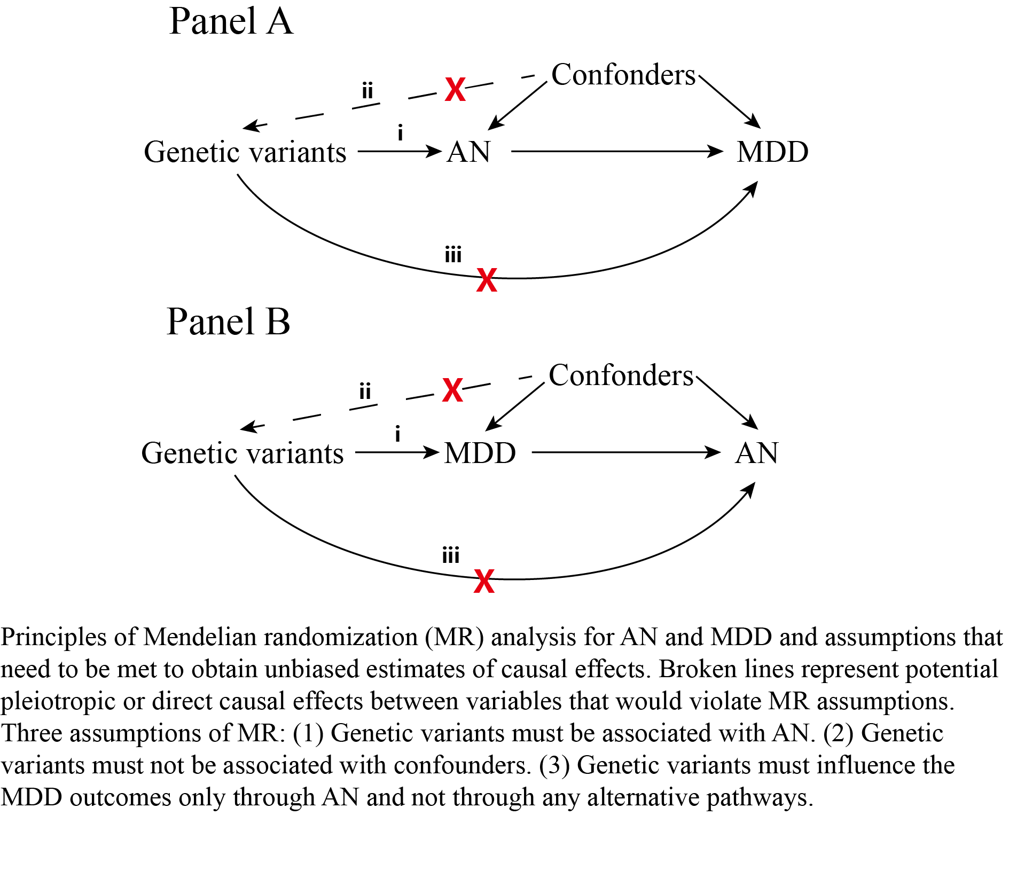

Fig 1 Study design and principles of MR

### Data Sources for MR Analyses and Selection of the Genetic Instruments

To assess whether AN associated with increased odds of MDD, We conducted Mendelian randomization (MR) analyses using the latest Genome-Wide Association Study (GWAS) for Anorexia Nervosa (AN) conducted by Watson et al. [16]. The GWAS included 16992 AN patients and 55525 controls with European ancestry, we used the 11 genome-wide significant SNPs identified in the study as the genetic instrument. The MDD GWAS comprised a total of 170756 participants with MDD and 329443 individuals of European ancestry serving as controls[17]. The data for this study were sourced from the PGC and UK Biobank .All individuals included in the dataset satisfied the international consensus criteria for a lifetime diagnosis of depression. These criteria were established through the use of structured diagnostic instruments administered by trained interviewers, clinician-administered checklists, or review of medical records.

### Selection of instrumental variables (IVs)

To conduct a Mendelian randomization analysis, it is crucial that genetic variants are associated with the exposure of interest but not potential confounders. In order to fulfill the first assumption of MR analysis, which necessitates a strong association between the instrument (SNP) and the exposure (AN), we specifically selected SNPs as instruments that exhibited a significant association with AN at a genome-wide level (p < 5 × 10−7). We only included SNPs in our analysis that had no risk of linkage disequilibrium (LD) (with an LD measure of r2<0.001) and were at a minimum distance of 10,000 base pairs (kb) apart from each other. Furthermore, we calculated the F statistics for each SNP solely and cumulatively by the following equation: F=R2×(N - 2)/(1 - R2). R2 denotes the variance of exposure explained by each IV. IVs with F statistics of less than 10 were considered weak instruments and would be excluded for MR analysis[18]. Ultimately, we obtained 11 SNPs as instrumental variables (IVs).

### Mendelian randomization Analysis

In order to evaluate the causal link between exposure variables and the result, we used inverse variance weighting (IVW), MR-Egger, weighted median, and weighted mode in our study. The classic IVW method successfully uses weighted linear regression to predict the relationships between the instrumental factors and the result by combining Wald ratio estimates from the instrumental variables through meta-analysis. It benefits unbiased estimates by limiting the instrumental variable intercept to zero in the absence of horizontal pleiotropy. While taking into consideration some pleiotropy, MR-Egger uses the Inside assumption and mostly represents the dose-response connection between instrumental factors and outcomes. For the purpose of avoid Type 1 mistakes and incorporate possibly less restrictive genetic variations, we employed the Weighted Median method. As long as the majority of instrumental variables yield reliable causal estimates, the Weighted Mode method remains trustworthy, particularly in the presence of heterogeneity .When there are methodological inconsistencies, we emphasize IVW as our primary outcome. We did data harmonization, deleted SNPs with equivocal strand information, and excluded palindromic SNPs to prevent allele effect on the causative association between AN and MDD in order to assure consistency in our study.

We conducted tests for horizontal pleiotropy and outliers using the MR-Egger and MR Pleiotropy RESidual Sum and Outlier tests. Specifically, MR-Egger was employed as an initial step to ascertain the presence of horizontal pleiotropy. If the p-value exceeded 0.05, it indicated the absence of significant horizontal pleiotropy. MR-PRESSO, known for its higher accuracy compared to MR-Egger, was utilized for detecting horizontal pleiotropy and outliers effectively. Subsequently, Conchrane's Q test was applied to assess heterogeneity among instrument variables. The stability of the results and the identification of outliers were carried out through a leave-one-out sensitivity analysis. To enhance result reliability, we conducted a sensitivity analysis using a fixed effects model. Additionally, we conducted a reverse causality study to investigate the reverse causal relationship. A notional causal effect is said to exist when the p value is between 0.05 and the corrected value. This study's design was influenced by the STROBE-MR guideline.

### Instrumental strength and power calculation

We calculated the statistical power using the mRnd website (https://shiny.cnsgenomics.com/mRnd/)[19].The statistical tests and MR PRESSO analysis were conducted using R software version 4.2.2 and the R-package "TwoSampleMR" (https://github.com/MRCIEU/TwoSampleMR) developed by Hemani et al[20].

## RESULTS

A bidirectional, two-sample MR analysis was used to investigate the causative link between MDD levels and the risk of AN. Our MR findings demonstrated a bidirectional causal link between genetic vulnerability to MDD and an elevated risk of AN.

## Causal effects of MDD on AN

**Selection of instrumental variables**

The publicly accessible MDD GWAS dataset was retrieved using the R programming language. We included 50 SNPs that were both substantially (p < 5*10-8) linked with exposure (MDD) and independent (r2 < 0.001 and KB > 10,000). Some SNPs not detected in the result dataset were eliminated when utilizing these SNPs to correlate with the concluding GWAS dataset. One SNP was lost in the MDD-AN analysis groups (rs35469634). After that, we removed two palindromic SNPs with intermediate allele frequencies from all three investigations (rs2876520 and rs4730387). Finally, 40 SNPs were identified as IVs in the MDD versus AN analysis (Supplementary Table 1). All F-statistics for the instrumental variables utilized in the final analysis were more extensive than 10 (mean value of 34, range of 44). It was suggested that these are robust IVs and satisfy the strong correlation assumption of MR.

**Two-sample Mendelian randomization analysis**

IVW was used as the primary method of analysis, which revealed a causal relationship between genetic susceptibility to MDD and increased risk of AN (OR: 1.520, 95% CI: 1.190-1.950, p<0.001). Secondary analysis methods included MR-Egger (OR: 1.722, 95% CI: 0.437-6.785, p=0.441), weighted median (OR: 1.474, 95% CI: 1.122-1.936, p = 0.005), weighted mode (OR: 1.371, 95% CI: 0.738-2.546, p = 0.325). The resulting OR values were all greater than 1 after transforming the relative risk ratios (Fig 2).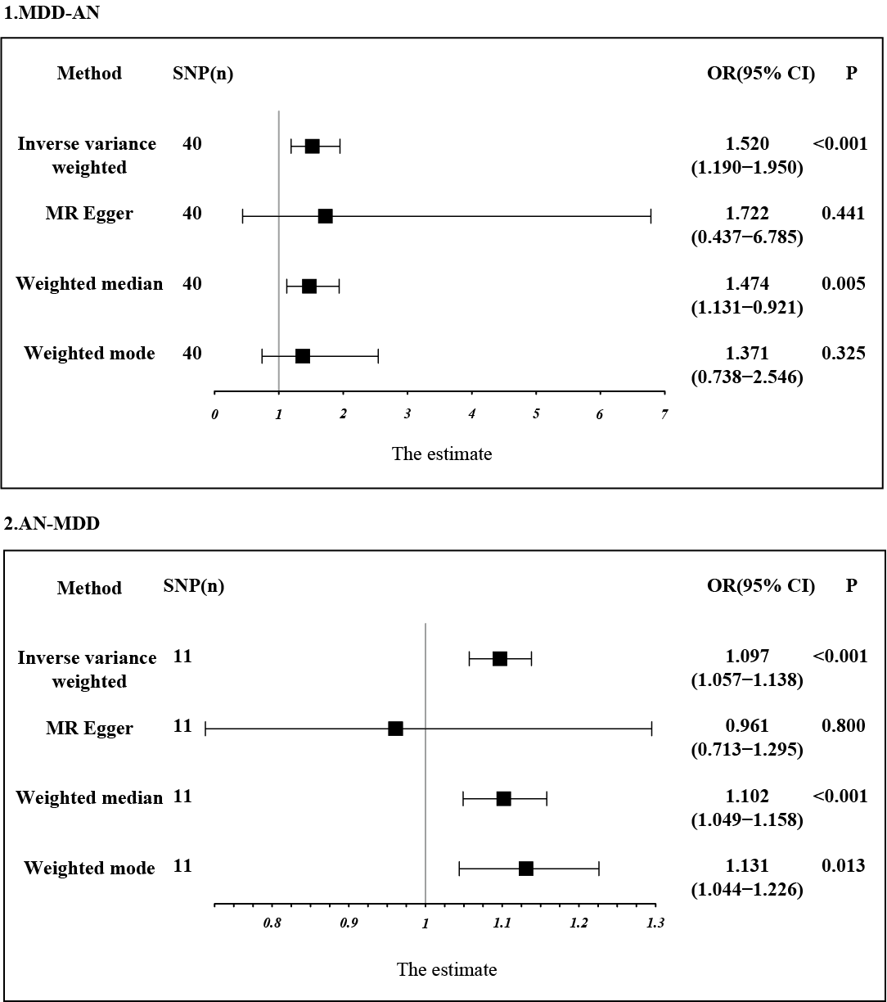

Fig2 Estimation of the causal relationship between MDD and AN using different MR methods. An OR value greater than 1 suggests that the exposure indicator is a risk factor while the opposite is a protective factor.

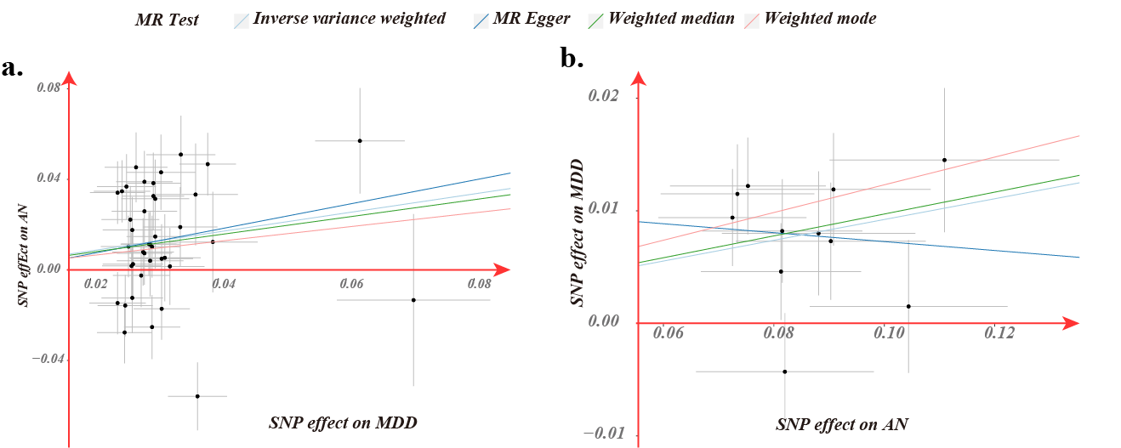

Fig3 Scatter plot of genetic correlation between MDD and migraine by different MR analysis methods.

**Sensitivity analysis and visualization**

MR-Egger regression and IVW analyses were used to detect heterogeneity.MR-Egger regression (MDD-migraine: Cochran's Q = 98.036, p = 3*10-7) and IVW (Cochran's Q = 98.119, p = 5*10-7) showed significant heterogeneity in the studies, so we emphasize weighted median as our primary outcome (OR, 1.474, 95% CI: 1.122-1.936, p = 0.004). The funnel plot used to show heterogeneity is shown in Supplementary Figure S1.The MR-Egger intercept did not show horizontal multidirectionality (Egger intercept, -0.003, p = 0.858). We used a culling method to remove SNPs one by one to determine whether causal associations were caused by a single IV, and the final results showed that the results of the TSMR analysis were robust (Fig. 4).

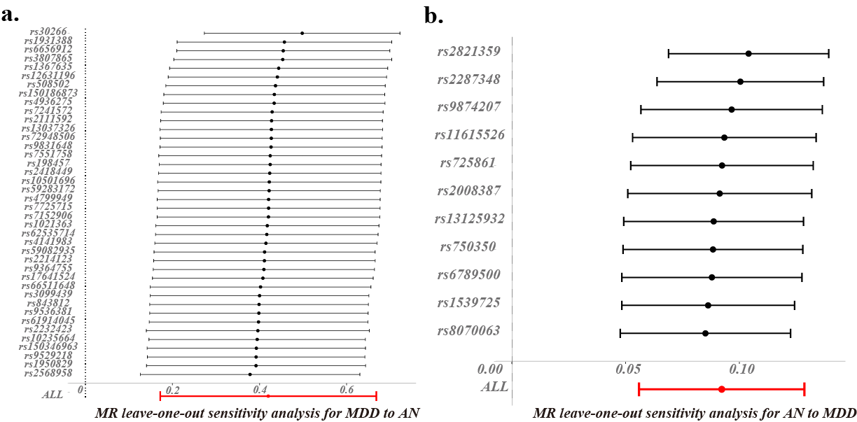

Fig4 Bidirectional leave-one-out sensitivity analysis between MDD and AN. Red lines represent estimates from IVW tests. IVW: inverse variance weighted.

## Reverse TSMR analysis

In contrast, in TSMR, AN was the exposure factor, and MDD was the outcome factor. To obtain more IVs, we set the value of p to less than 5 × 10–7.  In addition, after the setting of chain imbalance (r2 < 0.001 and KB > 10,000), we ensured that the included IVs were following the core assumptions of MR and removing SNPs not present in the outcome dataset, and removing palindromic SNPs with intermediate allele frequencies. Finally, for the exposure datasets of AN, 11 SNPs were included for MR analysis, respectively. The F-statistics were all greater than 20 (mean: 23, range: 21–31). The MR results did support a relationship between genetic AN susceptibility and an increased risk of MDD causality (IVW: OR, 1.097, 95% CI, 1.057–1.138, p = 9*10-7). The heterogeneity test revealed that heterogeneity existed in the MA-MDD analysis (MR-Egger: Cochran’s Q, 10.7, 0.296; IVW: Cochran’s Q = 11.6, p = 0.312). For the horizontal pleiotropy test, the MR-Egger intercept did not detect any abnormalities in the analysis between AN level and MDD risk (Egger intercept= 0.011, p= 0.405).

## Discussion

In this study, we used bidirectional two-sample Mendelian random analysis to assess the interaction between AN and MDD in an attempt to unravel the association between the two diseases. The results of our analyses were largely consistent across multiple MR analysis methods, which suggests that our results are reliable.

Previous research has indicated that AN and MDD often coexist and mutually reinforce each other, resulting in a complex symptom profile for patients[21]. Extensive research has investigated the shared influences between AN and MDD. The impact of eating behavior on mood has been extensively explored. Physiologically, AN can result in severe malnutrition and weight loss, leading to disruption of normal bodily functions[22]. These physiological changes directly alter the equilibrium of brain chemicals, including serotonin and neurotransmitters like dopamine, which can trigger or exacerbate depressive symptoms[23]. In addition, AN-related abnormalities in the Hypothalamic-Pituitary-Adrenal (HPA) axis and the reduction of white matter in the brain due to abnormal energy metabolism contribute to the development of depression[24-26]. Furthermore, patients with AN frequently experience excessive concerns and dissatisfaction regarding their weight and appearance, giving rise to negative emotions such as low self-esteem, anxiety, and self-loathing[27]. These psychological factors are closely associated with the manifestation of depressive symptoms. Moreover, individuals with AN often encounter social pressure and discrimination, which further intensify their depressive feelings[28]. Feelings of isolation, helplessness, and underappreciation resulting from negative social reactions can significantly contribute to or exacerbate depressive symptoms.

MDD often manifests alongside various psychological issues, including negative emotions, feelings of inferiority, self-loathing, and helplessness[29]. These psychological problems can trigger adverse emotional responses towards appetite and eating behavior, ultimately leading to appetite loss and the development of anorexia[30]. Depressive symptoms often diminish the patient's sense of taste and pleasure when it comes to food, causing them to perceive it as bland and unappetizing. Consequently, this perception fuels anorexic behaviors. Additionally, individuals with depression may seek to exert control over their lives by implementing restrictions on their food intake. They may view anorexia as a means of self-punishment[31], driven by the belief that they are unworthy of experiencing the enjoyment and satisfaction that food can provide.

Additionally, there may be shared genetic risk factors between AN and MDD. The latest GWAS study also indicates a significant positive correlation between AN (anorexia nervosa) and MDD (major depressive disorder)[16]. This suggests that genetic factors may play an important role in the pathogenesis of both disorders. Specifically, these studies have found associations between certain genetic variants and increased risk for AN and MDD. These genetic variants may involve functions related to neurotransmitter systems, immune system, and neurodevelopment, among others. However, further research is needed to gain a deeper understanding of the genetic associations between AN and MDD, as well as the specific mechanisms by which these genetic variants contribute to the development of these disorders.Our findings indicate a reciprocal association between AN and MDD, suggesting a bidirectional causal relationship between the two conditions. These results are in line with previous studies and provide further evidence for the impact of genetic factors on the development of AN and MDD.

It is significant to interpret the findings of this study within the context of its limitations and the broader limitations of Mendelian randomization methodology. Firstly, owing to the limited number of AN-associated SNPs, we opted for a more lenient p-value threshold, potentially influencing the precision of the outcomes. Additionally, it is worth noting that there may be some duplication of data between the two genome-wide association studies (GWAS) used, as both studies partially overlap with the UK Biobank. This potential for bias should be acknowledged during interpretation. Furthermore, while MR serves as a valuable proxy for validating effects, it is important to recognize that genetic variation reflects lifetime exposure rather than the short-term nature of therapeutic interventions. Lastly, it is important to acknowledge that our use of the GWAS depression did not account for the diversity of MDD, particularly atypical and melancholic depression. This lack of consideration has implications for the interpretation of the results.

## Conclusion

In summary, the outcomes of this study suggest a plausible causal connection between genetic predisposition for Anorexia Nervosa (AN) and Major Depressive Disorder (MDD). These results underscore the importance of antidepressant interventions for individuals afflicted with AN. Although our findings align with prior observational research, it is imperative to substantiate these conclusions through extensive prospective studies and in-depth mechanistic inquiries.

[1] 王向群，王高华, 中国进食障碍防治指南[M], 北京：中华医学电子音像出版社 ( 2015).

[2] S. Paolacci, A.K. Kiani, E. Manara, T. Beccari, M.R. Ceccarini, L. Stuppia, P. Chiurazzi, L. Dalla Ragione, M. Bertelli, Genetic contributions to the etiology of anorexia nervosa: New perspectives in molecular diagnosis and treatment, Mol Genet Genomic Med 8 (2020) e1244.

[3] S. Zipfel, K.E. Giel, C.M. Bulik, P. Hay, U. Schmidt, Anorexia nervosa: aetiology, assessment, and treatment, Lancet Psychiatry 2 (2015) 1099-1111.

[4] Z. Pan, C. Park, E. Brietzke, H. Zuckerman, C. Rong, R.B. Mansur, D. Fus, M. Subramaniapillai, Y. Lee, R.S. McIntyre, Cognitive impairment in major depressive disorder, CNS Spectr 24 (2019) 22-29.

[5] M. Zhdanava, D. Pilon, I. Ghelerter, W. Chow, K. Joshi, P. Lefebvre, J.J. Sheehan, The Prevalence and National Burden of Treatment-Resistant Depression and Major Depressive Disorder in the United States, J Clin Psychiatry 82 (2021).

[6] P. Westmoreland, M.J. Krantz, P.S. Mehler, Medical Complications of Anorexia Nervosa and Bulimia, Am J Med 129 (2016) 30-37.

[7] B.M. Santos, A.F. Haynos, Difficulties with positive emotion regulation in anorexia nervosa, Eur Eat Disord Rev 31 (2023) 520-528.

[8] A. Pleplé, C. Lalanne, C. Huas, L. Mattar, M. Hanachi, M.F. Flament, I. Carchon, F. Jouen, S. Berthoz, N. Godart, Nutritional status and anxious and depressive symptoms in anorexia nervosa: a prospective study, Sci Rep 11 (2021) 771.

[9] A.B. Levy, K.N. Dixon, Anorexia nervosa and depression--reconsidering diagnostic criteria, Br J Psychiatry 145 (1984) 92-93.

[10] S. Marucci, L.D. Ragione, G. De Iaco, T. Mococci, M. Vicini, E. Guastamacchia, V. Triggiani, Anorexia Nervosa and Comorbid Psychopathology, Endocr Metab Immune Disord Drug Targets 18 (2018) 316-324.

[11] L.M. Thornton, E. Welch, M.A. Munn-Chernoff, P. Lichtenstein, C.M. Bulik, Anorexia Nervosa, Major Depression, and Suicide Attempts: Shared Genetic Factors, Suicide Life Threat Behav 46 (2016) 525-534.

[12] P. Sekula, M.F. Del Greco, C. Pattaro, A. Köttgen, Mendelian randomization as an Approach to Assess Causality Using Observational Data, J Am Soc Nephrol 27 (2016) 3253-3265.

[13] S. Burgess, S.G. Thompson, Interpreting findings from Mendelian randomization using the MR-Egger method, Eur J Epidemiol 32 (2017) 377-389.

[14] J. Bowden, M.V. Holmes,

Meta-analysis and Mendelian randomization: A review, Res Synth Methods 10 (2019) 486-496.

[15] O.O. Yavorska, S. Burgess, MendelianRandomization: an R package for performing Mendelian randomization analyses using summarized data, Int J Epidemiol 46 (2017) 1734-1739.

[16] H.J. Watson, Z. Yilmaz, L.M. Thornton, C. Hübel, J.R.I. Coleman, H.A. Gaspar, J. Bryois, A. Hinney, V.M. Leppä, M. Mattheisen, S.E. Medland, S. Ripke, S. Yao, P. Giusti-Rodríguez, K.B. Hanscombe, K.L. Purves, R.A.H. Adan, L. Alfredsson, T. Ando, O.A. Andreassen, J.H. Baker, W.H. Berrettini, I. Boehm, C. Boni, V.B. Perica, K. Buehren, R. Burghardt, M. Cassina, S. Cichon, M. Clementi, R.D. Cone, P. Courtet, S. Crow, J.J. Crowley, U.N. Danner, O.S.P. Davis, M. de Zwaan, G. Dedoussis, D. Degortes, J.E. DeSocio, D.M. Dick, D. Dikeos, C. Dina, M. Dmitrzak-Weglarz, E. Docampo, L.E. Duncan, K. Egberts, S. Ehrlich, G. Escaramís, T. Esko, X. Estivill, A. Farmer, A. Favaro, F. Fernández-Aranda, M.M. Fichter, K. Fischer, M. Föcker, L. Foretova, A.J. Forstner, M. Forzan, C.S. Franklin, S. Gallinger, I. Giegling, J. Giuranna, F. Gonidakis, P. Gorwood, M.G. Mayora, S. Guillaume, Y. Guo, H. Hakonarson, K. Hatzikotoulas, J. Hauser, J. Hebebrand, S.G. Helder, S. Herms, B. Herpertz-Dahlmann, W. Herzog, L.M. Huckins, J.I. Hudson, H. Imgart, H. Inoko, V. Janout, S. Jiménez-Murcia, A. Julià, G. Kalsi, D. Kaminská, J. Kaprio, L. Karhunen, A. Karwautz, M.J.H. Kas, J.L. Kennedy, A. Keski-Rahkonen, K. Kiezebrink, Y.R. Kim, L. Klareskog, K.L. Klump, G.P.S. Knudsen, M.C. La Via, S. Le Hellard, R.D. Levitan, D. Li, L. Lilenfeld, B.D. Lin, J. Lissowska, J. Luykx, P.J. Magistretti, M. Maj, K. Mannik, S. Marsal, C.R. Marshall, M. Mattingsdal, S. McDevitt, P. McGuffin, A. Metspalu, I. Meulenbelt, N. Micali, K. Mitchell, A.M. Monteleone, P. Monteleone, M.A. Munn-Chernoff, B. Nacmias, M. Navratilova, I. Ntalla, J.K. O'Toole, R.A. Ophoff, L. Padyukov, A. Palotie, J. Pantel, H. Papezova, D. Pinto, R. Rabionet, A. Raevuori, N. Ramoz, T. Reichborn-Kjennerud, V. Ricca, S. Ripatti, F. Ritschel, M. Roberts, A. Rotondo, D. Rujescu, F. Rybakowski, P. Santonastaso, A. Scherag, S.W. Scherer, U. Schmidt, N.J. Schork, A. Schosser, J. Seitz, L. Slachtova, P.E. Slagboom, M.C.T. Slof-Op 't Landt, A. Slopien, S. Sorbi, B. Świątkowska, J.P. Szatkiewicz, I. Tachmazidou, E. Tenconi, A. Tortorella, F. Tozzi, J. Treasure, A. Tsitsika, M. Tyszkiewicz-Nwafor, K. Tziouvas, A.A. van Elburg, E.F. van Furth, G. Wagner, E. Walton, E. Widen, E. Zeggini, S. Zerwas, S. Zipfel, A.W. Bergen, J.M. Boden, H. Brandt, S. Crawford, K.A. Halmi, L.J. Horwood, C. Johnson, A.S. Kaplan, W.H. Kaye, J.E. Mitchell, C.M. Olsen, J.F. Pearson, N.L. Pedersen, M. Strober, T. Werge, D.C. Whiteman, D.B. Woodside, G.D. Stuber, S. Gordon, J. Grove, A.K. Henders, A. Juréus, K.M. Kirk, J.T. Larsen, R. Parker, L. Petersen, J. Jordan, M. Kennedy, G.W. Montgomery, T.D. Wade, A. Birgegård, P. Lichtenstein, C. Norring, M. Landén, N.G. Martin, P.B. Mortensen, P.F. Sullivan, G. Breen, C.M. Bulik, Genome-wide association study identifies eight risk loci and implicates metabo-psychiatric origins for anorexia nervosa, Nat Genet 51 (2019) 1207-1214.

[17] D.M. Howard, M.J. Adams, T.K. Clarke, J.D. Hafferty, J. Gibson, M. Shirali, J.R.I. Coleman, S.P. Hagenaars, J. Ward, E.M. Wigmore, C. Alloza, X. Shen, M.C. Barbu, E.Y. Xu, H.C. Whalley, R.E. Marioni, D.J. Porteous, G. Davies, I.J. Deary, G. Hemani, K. Berger, H. Teismann, R. Rawal, V. Arolt, B.T. Baune, U. Dannlowski, K. Domschke, C. Tian, D.A. Hinds, M. Trzaskowski, E.M. Byrne, S. Ripke, D.J. Smith, P.F. Sullivan, N.R. Wray, G. Breen, C.M. Lewis, A.M. McIntosh, Genome-wide meta-analysis of depression identifies 102 independent variants and highlights the importance of the prefrontal brain regions, Nat Neurosci 22 (2019) 343-352.

[18] J. Hu, J. Song, Z. Chen, J. Yang, Q. Shi, F. Jin, Q. Pang, X. Chang, Y. Tian, Y. Luo, L. Chen, Reverse causal relationship between periodontitis and shortened telomere length: Bidirectional two-sample Mendelian random analysis, Front Immunol 13 (2022) 1057602.

[19] K.J. Yin, J.X. Huang, P. Wang, X.K. Yang, S.S. Tao, H.M. Li, J. Ni, H.F. Pan, No Genetic Causal Association Between Periodontitis and Arthritis: A Bidirectional Two-Sample Mendelian randomization Analysis, Front Immunol 13 (2022) 808832.

[20] G. Hemani, J. Zheng, B. Elsworth, K.H. Wade, V. Haberland, D. Baird, C. Laurin, S. Burgess, J. Bowden, R. Langdon, V.Y. Tan, J. Yarmolinsky, H.A. Shihab, N.J. Timpson, D.M. Evans, C. Relton, R.M. Martin, G. Davey Smith, T.R. Gaunt, P.C. Haycock, The MR-Base platform supports systematic causal inference across the human phenome, Elife 7 (2018).

[21] M. Panero, E. Marzola, T. Tamarin, A. Brustolin, G. Abbate-Daga, Comparison between inpatients with anorexia nervosa with and without major depressive disorder: Clinical characteristics and outcome, Psychiatry Res 297 (2021) 113734.

[22] J. Herrou, N. Godart, A. Etcheto, S. Kolta, N. Barthe, A.Y. Maugars, T. Thomas, C. Roux, K. Briot, Absence of relationships between depression and anxiety and bone mineral density in patients hospitalized for severe anorexia nervosa, Eat Weight Disord 26 (2021) 1975-1984.

[23] X. Ma, J. Cao, H. Zheng, X. Mei, M. Wang, H. Wang, Y. Shuai, Y. Shen, Peripheral body temperature rhythm is associated with suicide risk in major depressive disorder: a case-control study, Gen Psychiatr 34 (2021) e100219.

[24] M. Kennis, L. Gerritsen, M. van Dalen, A. Williams, P. Cuijpers, C. Bockting, Prospective biomarkers of major depressive disorder: a systematic review and meta-analysis, Mol Psychiatry 25 (2020) 321-338.

[25] E.A. Lawson, D. Donoho, K.K. Miller, M. Misra, E. Meenaghan, J. Lydecker, T. Wexler, D.B. Herzog, A. Klibanski, Hypercortisolemia is associated with severity of bone loss and depression in hypothalamic amenorrhea and anorexia nervosa, J Clin Endocrinol Metab 94 (2009) 4710-4716.

[26] R. Wheatland, Chronic ACTH autoantibodies are a significant pathological factor in the disruption of the hypothalamic-pituitary-adrenal axis in chronic fatigue syndrome, anorexia nervosa and major depression, Med Hypotheses 65 (2005) 287-295.

[27] C.L. Dahlgren, B. Lask, N.I. Landrø, Ø. Rø, Neuropsychological functioning in adolescents with anorexia nervosa before and after cognitive remediation therapy: a feasibility trial, Int J Eat Disord 46 (2013) 576-581.

[28] J. Arkell, P. Robinson, A pilot case series using qualitative and quantitative methods: biological, psychological and social outcome in severe and enduring eating disorder (anorexia nervosa), Int J Eat Disord 41 (2008) 650-656.

[29] E. Pitsillou, S.M. Bresnehan, E.A. Kagarakis, S.J. Wijoyo, J. Liang, A. Hung, T.C. Karagiannis, The cellular and molecular basis of major depressive disorder: towards a unified model for understanding clinical depression, Mol Biol Rep 47 (2020) 753-770.

[30] X. Gonda, P. Petschner, N. Eszlari, D. Baksa, A. Edes, P. Antal, G. Juhasz, G. Bagdy, Genetic variants in major depressive disorder: From pathophysiology to therapy, Pharmacol Ther 194 (2019) 22-43.

[31] M. Gander, K. Sevecke, A. Buchheim, Disorder-specific attachment characteristics and experiences of childhood abuse and neglect in adolescents with anorexia nervosa and a major depressive episode, Clin Psychol Psychother 25 (2018) 894-906.